How to install ntfs-3g drivers on Redhat and make nfts filesystem devices working

Redhat doesnot come with ntfs-3g drivers installed bydefault. We need to install this drivers manually to make ntfs (Windows File System) file system devices working on Linux. We need driver tar file to install drivers that is the first thing we need.
Lets get started.

1)You could find ntfg-3g driver tar file on this web. Go to web site, find Download section and download this file ntfs-3g_ntfsprogs-2017.3.23.
https://www.tuxera.com/community/open-source-ntfs-3fg/

2)open up your terminal and fire below commands to unzip tar file of ntfs-3g driver.

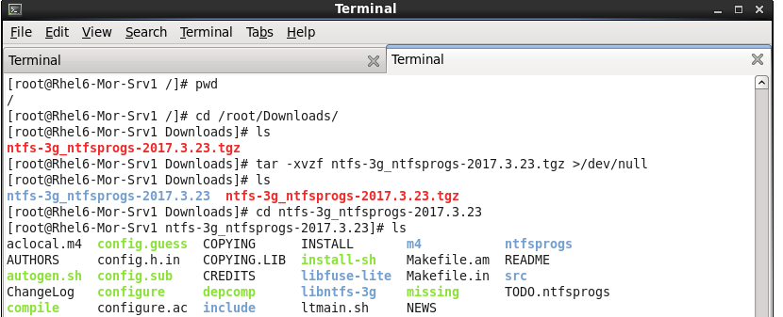

3)Installation: open your terminal and Then type: below commands. I have used output redirection to send commands output to file instead of screen /terminal coz output is too long.

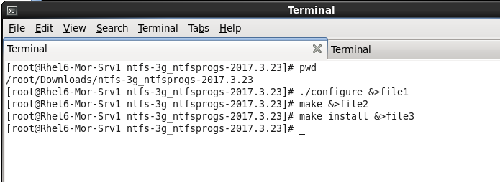
4)Usages:
If there was no error during installation then the NTFS volume can be mounted in read-write mode for everybody as follows.

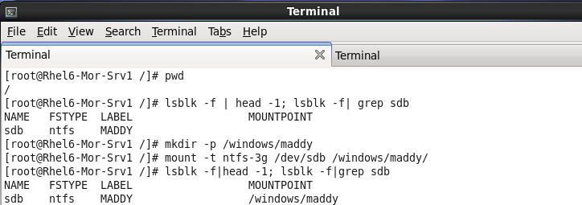

You can also make NTFS to be mounted during boot by adding the following line to the end of the /etc/fstab file:

/dev/sdb /windows/maddy ntfs-3g defaults 0 0

5)finally check if your ntfs file system device is mounted and working fine

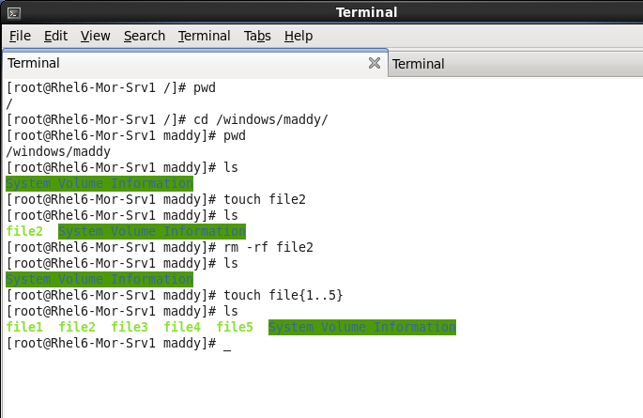

End.

